Is it efficient to use matrix multiplication to implement convolution operations? Why?
Reply: Yes, it is. Matrix multiplication is the core of deep learning. It can be used in the fully-connected layer, RNN, and convolution operations.
Convolution is the dot product of the filter and the input image patch. If we expand the filter as a 2-D matrix and the input block as another 2-D matrix, then multiplying the two matrices yields the same number. Unlike CNN, matrix multiplication has been extensively studied and optimized in recent decades and has become an important issue in many scientific fields. The process of expanding an image block into a matrix is called im2col (Image to Column). We rearrange the image into the columns of the matrix, and each column corresponds to an input block to which the convolution filter is applied.
The following figure shows a normal 3x3 convolution:
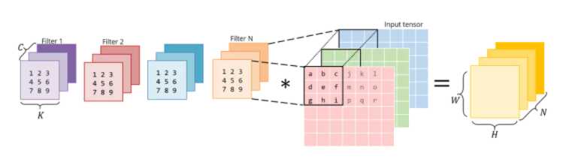
The following figure shows that the convolution operation implements in the form of matrix multiplication. The right part is the result of im2col of the matrix multiplication, which requires pixels to be copied from the original image to construct. The matrix on the left is the weights of the convolution, and they store in memory in this form.
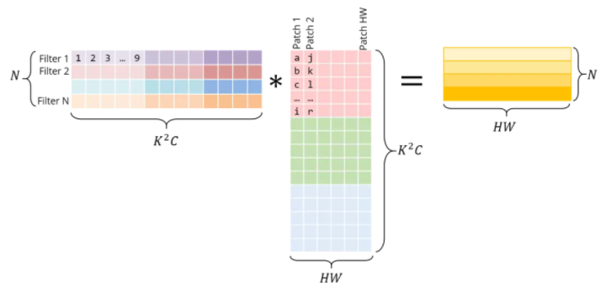
The matrix product directly yields the convolution output without additional "conversion" to the original form.
For visual simplicity, each image block is displayed as an independent individual here. In reality, there is often overlap between different image blocks, so im2col may cause memory overlap. The time spent generating Iim2col buffer and excessive vehicle memory must be offset by the acceleration achieved by matrix multiplication.

